Assignment -3

|  |  |
| --- | --- |
| *Assignment Date* | *30th October 2022* |
| *Student Name* | *Manikandan* |
| *Team ID* | *PNT2022TMID42862* |
| *Maximum Marks* | *2 Marks* |

Question:

# Create a Bucket in IBM object storage.

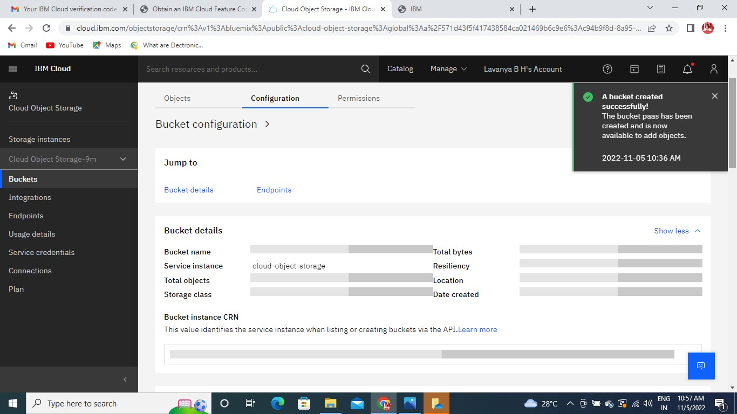

1. ***Upload an 5 images to ibm object storage and make it public. write html code todisplaying all the 5 images****.*

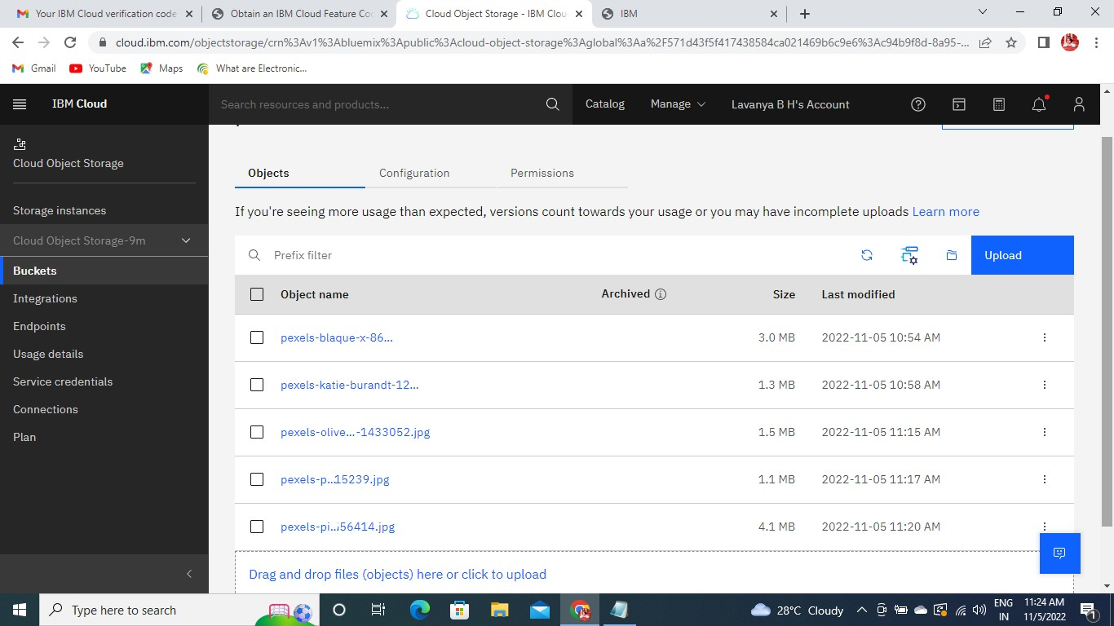

# Upload a css page to the object storage and use the same page in your HTML code.



<!DOCTYPE html>

<title>Canadian Scenario</title>

<head>

<style>img{ display: block; margin-left: auto; margin-right: auto; border: aqua; width: 50%;

}

</style>

</head>

<body style="background-color: aqua;">

<h1>CANADIAN SCENARIO</h1>

<img src=" <http://s3.jp-tok.cloud-object-storage.appdomain.cloud/scene1.jpeg>" alt="amazon" style="width:50%" >

<br>

<img src="<http://s3.jp-tok.cloud-object-storage.appdomain.cloud/scene2.jpeg>" alt=" google"width="600"

height="600">

<br>

<img src=" <http://s3.jp-tok.cloud-object-storage.appdomain.cloud/scene4.jpeg>" alt="ibm"width="600" height="600">

<br>

<img src="<http://s3.jp-tok.cloud-object-storage.appdomain.cloud/scene6.jpeg>" alt="box" width="600" height="600">

<br>

<img src="<http://s3.jp-tok.cloud-object-storage.appdomain.cloud/scene7.jpeg>"

alt="microsoft"width="600" height="600">

</body>

</html>

# Upload a css page to the object storage and use the same page in your HTML code.



Canadian scenario styling.html:

<!DOCTYPE html>

<title>Canadian scenario</title>

<head>

<style>img{ display: block; margin-left: auto; margin-right: auto; border: aqua; width: 50%;

}

Body{

style="border:rgb(15, 15, 15); border-width:5px;

border-style:double;text-align: center;font-family: Arial, Helvetica, sans-serif; background-color:powderblue"

}

</style>

</head>

<body style="background-color: aqua;">

<h1>CANADIAN SCENARIO</h1>

<img src=" <http://s3.jp-tok.cloud-object-storage.appdomain.cloud/img1.jpg>" alt="amazon" style="width:50%" >

<br>

<img src="<http://s3.jp-tok.cloud-object-storage.appdomain.cloud/img2.jpg>" alt="google"width="600" height="600">

<br>

<img src=" <http://s3.jp-tok.cloud-object-storage.appdomain.cloud/img3.jpg>"alt="ibm"width="600" height="600">

<br>

<img src="<http://s3.jp-tok.cloud-object-storage.appdomain.cloud/img4.jpg>" alt="box" width="600" height="600">

<br>

<img src="<http://s3.jp-tok.cloud-object-storage.appdomain.cloud/img5.jpg>" alt="microsoft"width="600" height="600">

</body>

</html> Style.css Body{

style="border:rgb(15, 15, 15); border-width:5px;

border-style:double;text-align: center;font-family: Arial, Helvetica, sans-serif; background-color:powderblue"

*}*

# Design a chatbot using IBM Watson assistant for hospital. Ex: User comes with query to know the branches for that hospital in your city. Submit the web URL of that chat bot as a assignment

https://web- chat.global.assistant.watson.appdomain.cloud/preview.html?backgroundImageURL=https% 3A%2F%2Fau-syd.assistant.watson.cloud.ibm.com%2Fpublic%2Fimages%2Fupx-f983893e- f570-488a- 85be-a88e5583f7de%3A%3A5ce2ca6a-dcae-478e-a90c- e6fa0ec864e9&integrationID=3b20919b- 747d-4417-b793-13e5240616e1&region=au- syd&serviceInstanceID=f983893e-f570-488a-85be- a88e5583f7de

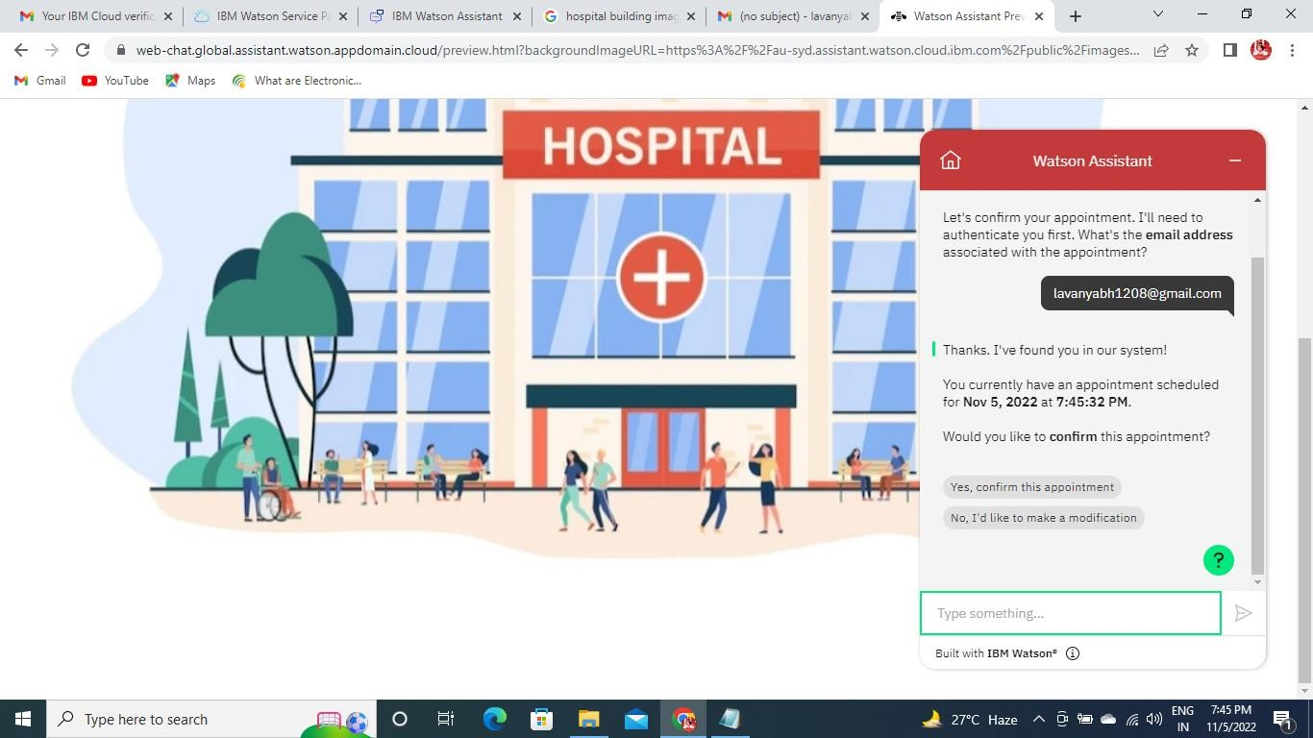

# Create Watson assistant service with 10 steps and use 3 conditions in it. Load that scriptin HTML page.

<!DOCTYPE html>

<title>abc hospital</title>

<style> body {

background: url(https://wallpaperaccess.com/full/1282794.jpg) no-repeat center center fixed;

-webkit-background-size: cover;

-moz-background-size: cover;

-o-background-size: cover; background-size: cover

}

</style>

<body>

<script> <script> window.watsonAssistantChatOptions =

{

integrationID: "2f598fa3-d76d-4766-b86f-92a28d85dae9", // The ID of this integration. region: "au- syd", // The region your integration is hosted in.

serviceInstanceID: "dd023609-f951-4da6-a246-92943dc5e937", // The ID of your service instance. onLoad: function(instance) { instance.render(); }

};

setTimeout(function(){

const t=document.createElement('script');

t.src="https://web-chat.global.assistant.watson.appdomain.cloud/versions/" + (window.watsonAssistantChatOptions.clientVersion || 'latest') +

"/WatsonAssistantChatEntry.js"; document.head.appendChild(t);

});

</script></script>

</body>

</html>

